First Library / PDF Page
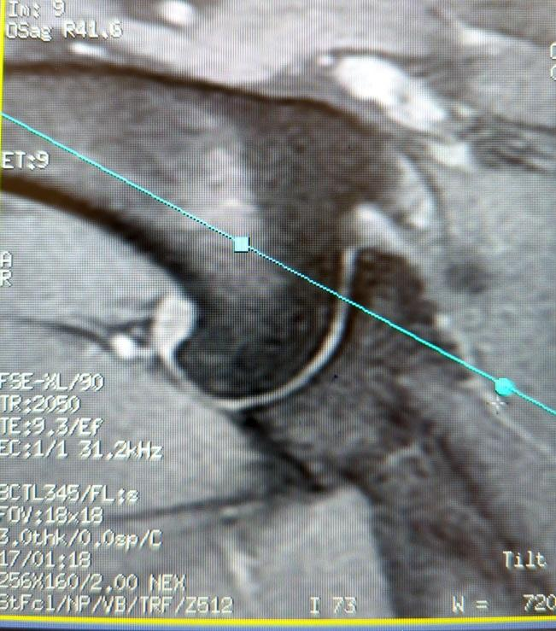
Veterinary Shoulder MRI Guide
Is our first attempt at sharing information from a slide show in PDF format. We'd like to know what you think of it. What would you like to see/know?
Contact us at: https://www.virtual-scan.com/contact if you would like to provide feedback or contribute.

