Remote Scanning from ACVIM
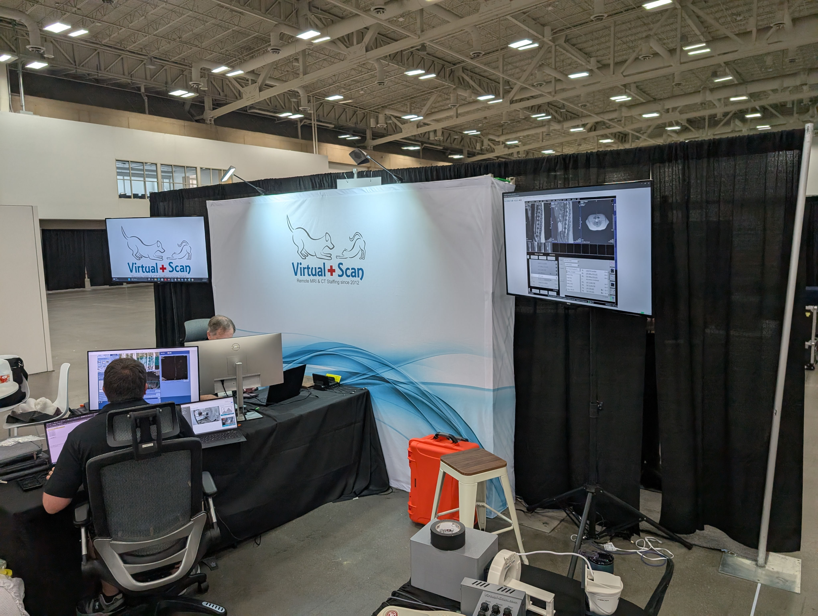
The crew was busy setting up the booth at ACVIM today, and while setting up and figuring things out, there were scans that needed to happen for patients. Scott and Gareth got into the groove while we tweaked the network and VPN configs for working well from the convention center. These are probably the first MRI scans ever done remotely from a convention center.

