Welcome and Intro
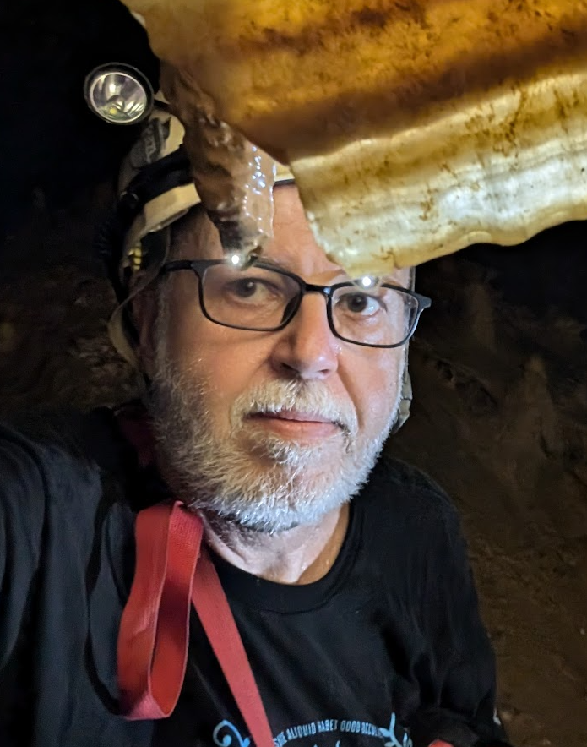
I'm Mike, the captive geek at Virtual Scan. I make things work and am testing the wiki. Greg Parker, the leader of the pack at Virtual Scan has a vision of a public wiki, dedicated to sharing everything they can about veterinary MRI. Over time, this will become a major educational resource for everyone involved in making Veterinary MRI better.
This is a test blog post created by a real human. Really

