Cervical Spine MRI

Scan Coverage
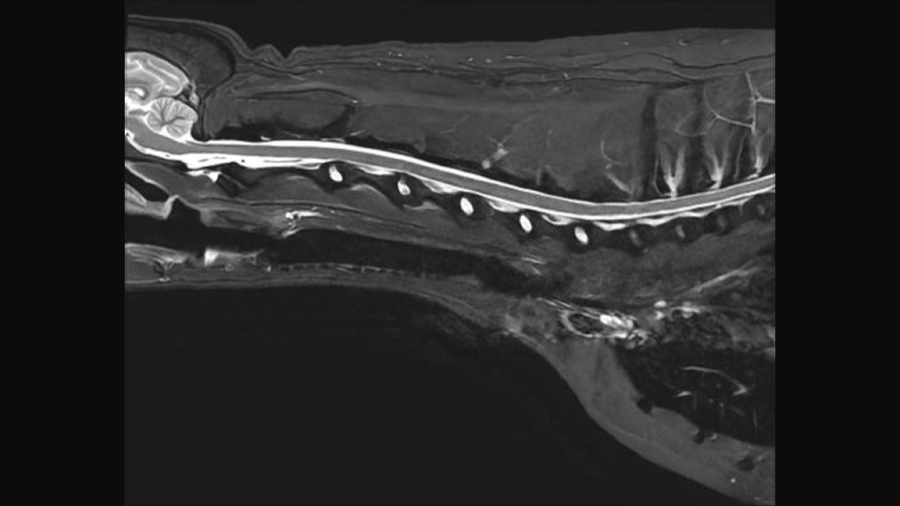
For each patient, the Field of View (FOV) should be re-sized to include the Cerebellum to include the T3 vertebral body.

