Intervertebral Disc Disease

Intervertebral Disc Disease (IVDD)
Intervertebral disc disease results from degeneration of the intervertebral disc and is most common in dogs. IVDD can occur in any section of the spine and in any breed of dog, though there are breed and location predilections. IVDD has both external factors like trauma, and genetic factors. The primary genetic predilections are between Chondrodystrophic Breeds and Non-chondrodystrophic Breeds. Herniation may refer to any displacement of the intervertebral disc or its components toward the spinal cord; protrusion refers to displacement of the annulus and extrusion refers to the ejection of nucleus pulposus material toward the spinal cord.
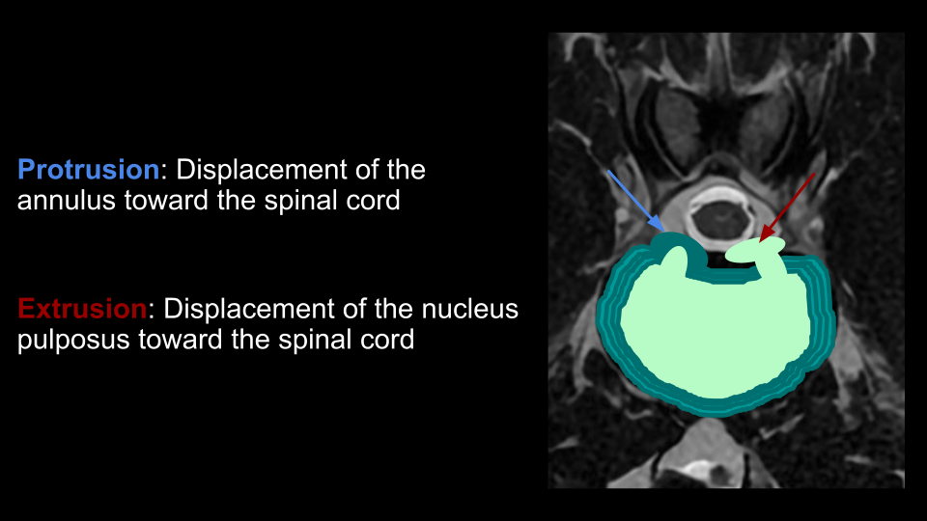
Chondrodystrophic breeds have strong genetic predispositions toward degeneration of the nucleus pulposus, which can become calcified and dehydrated at a young age, around 1-3 years old. These breeds are more prone to acute disc herniations and tend present more acutely.

Chondrodystrophic Breeds Examples
- Mini dachshund
- Corgi
- French Bulldog
- Cocker Spaniel
- Beagle
Non-chondrodystrophic breeds tend to undergo a slower degeneration of the disc, and both the nucleus pulposus and the annulus will degrade over time. 7 years or older is more typical for patients to present. These breeds are more prone to disc protrusions and chronic symptoms.

Non-chondrodystrophic Breeds Examples
- Labrador
- German Shepherd
- Rottweiler
- Doberman

Types of Disc Herniation
The combination of different external and genetic factors results in different kinds of disc herniations, which will be described here in 8 different categories. Click on each slide to expand
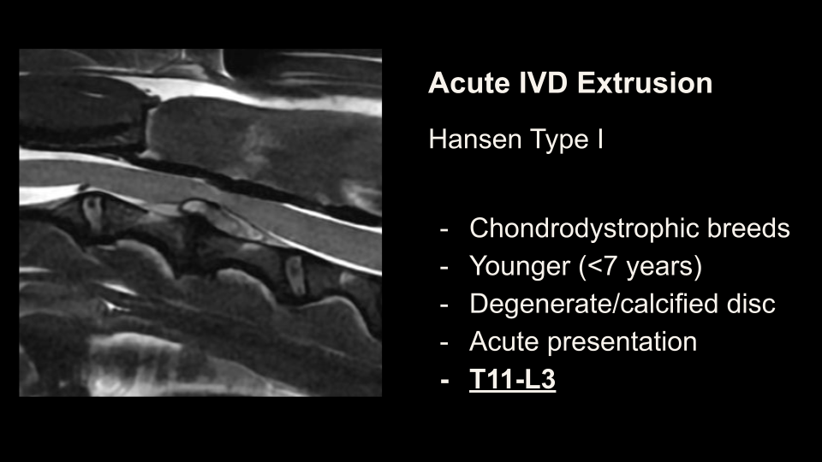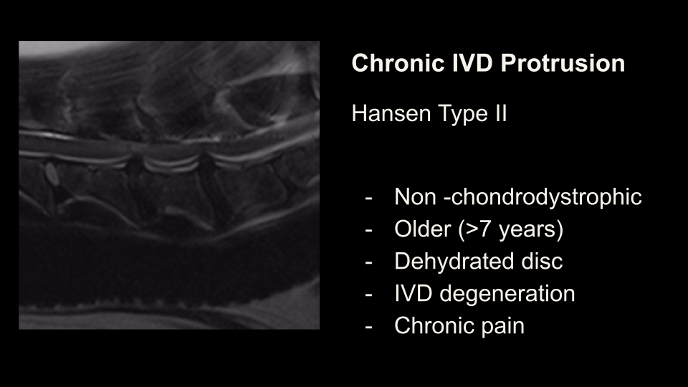
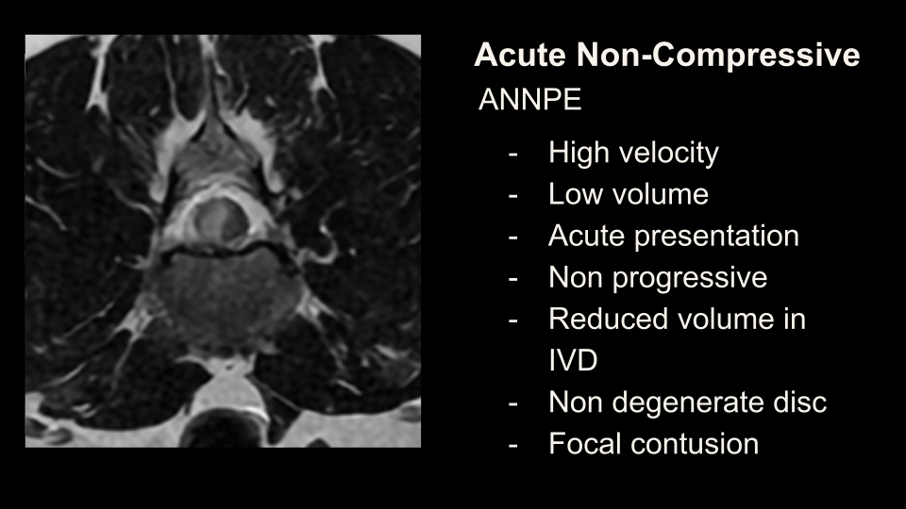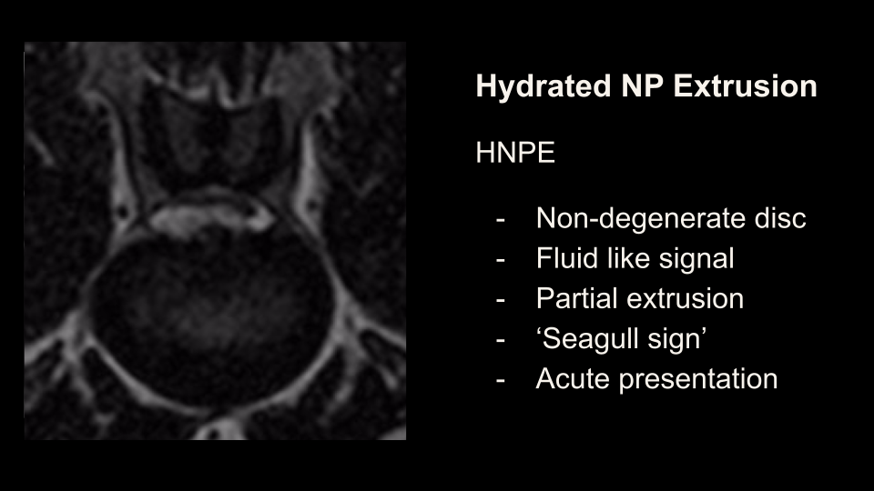
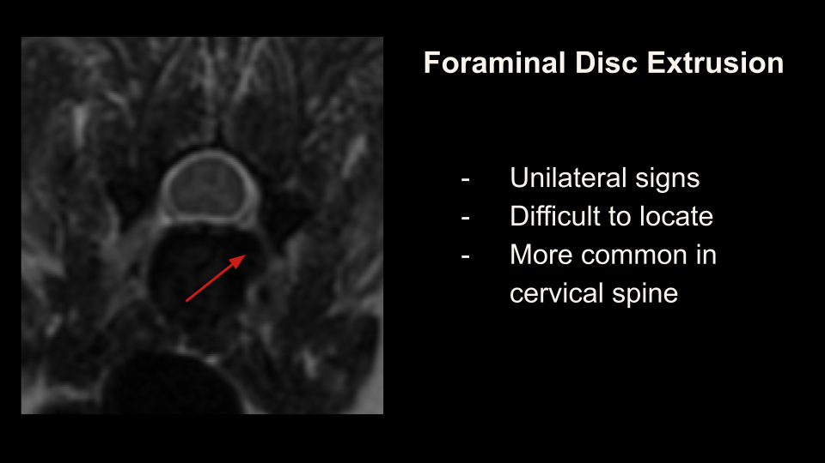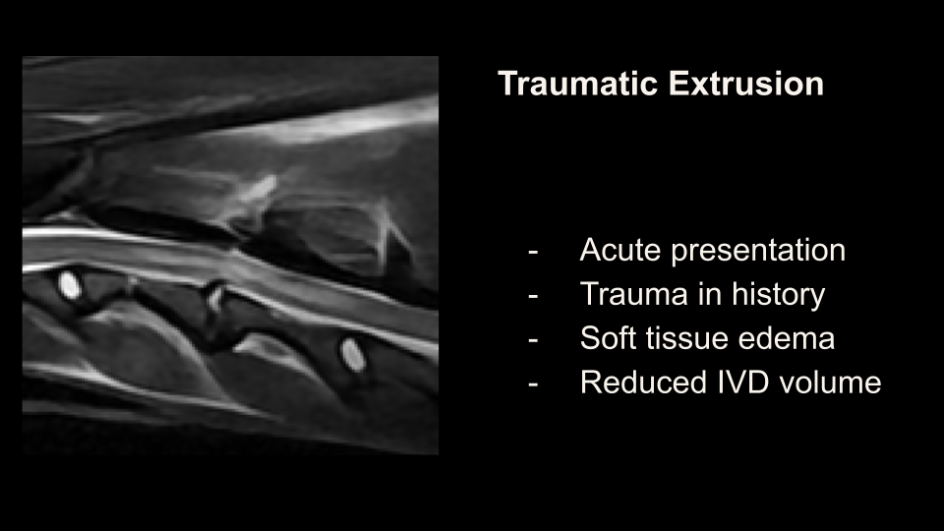
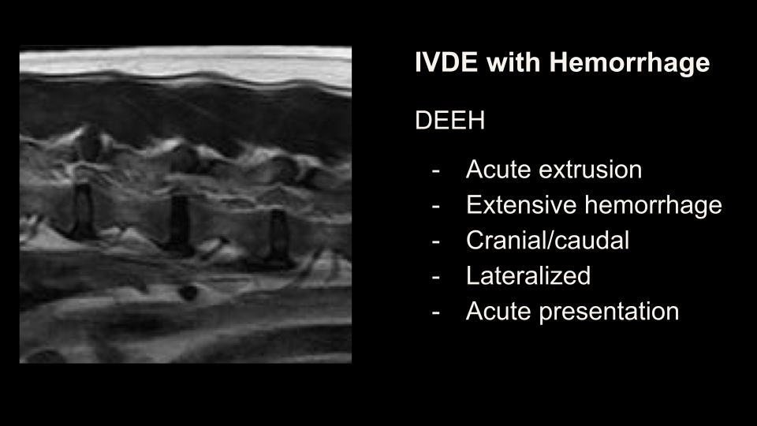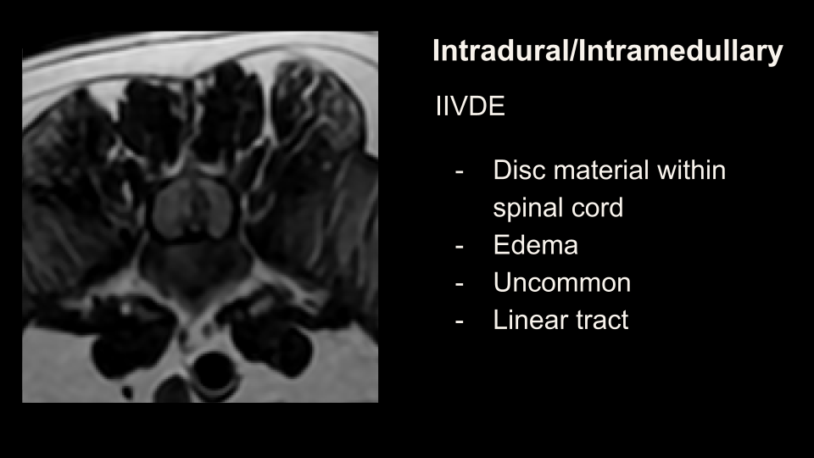

How to Find the Disc
Because it is too time consuming to scan 20 or more discs in the axial plane to find the one disc causing symptoms, the most important first step to scan a high quality sagittal T2, and looks for signs of disc extrusion, and then acquire focused axial slices. Below are slides displaying the various signs of disc extrusion that may be seen on that first sagittal T2.
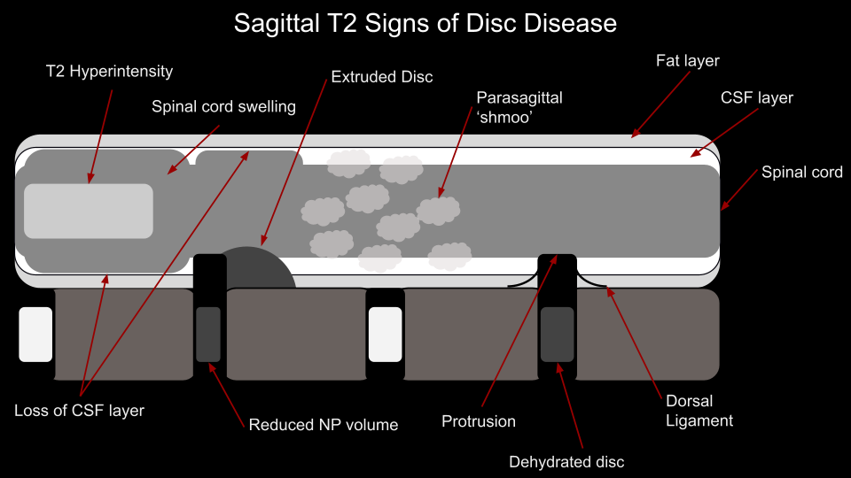
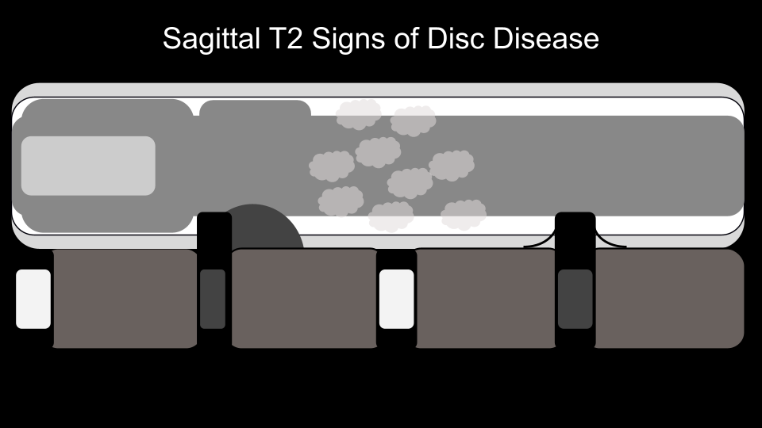
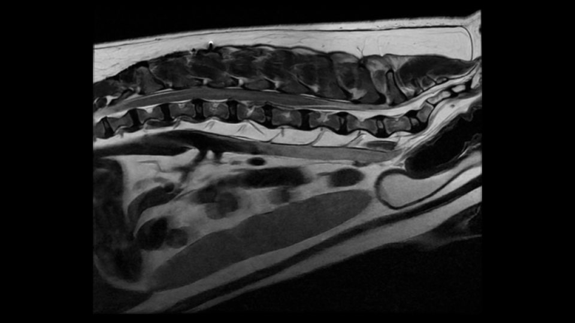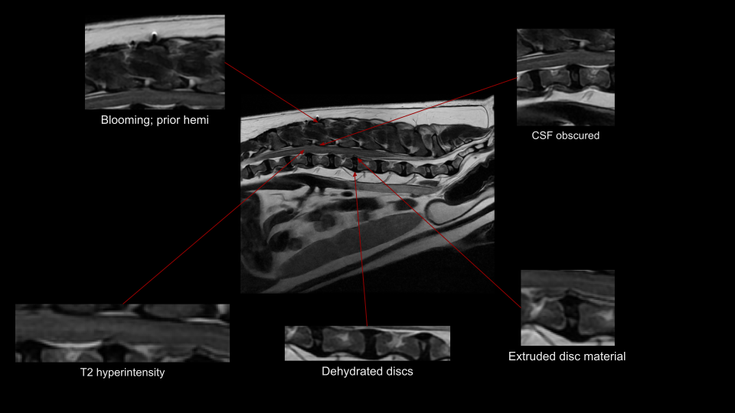
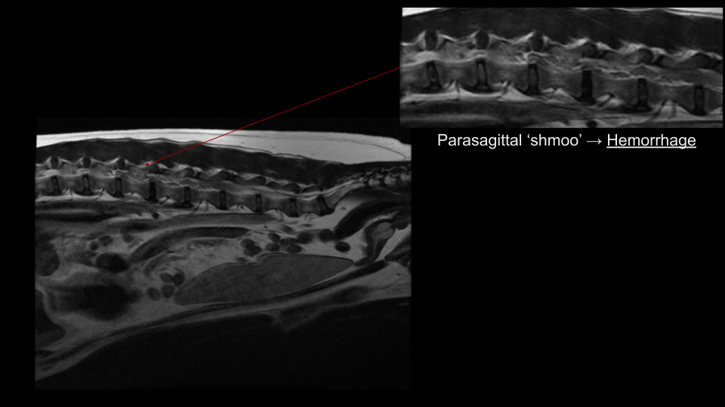

Case Examples


