Receiver Bandwidth

What is Receiver Bandwidth?
Receiver bandwidth, often shortened to just 'bandwidth' and not to be confused with transmit bandwidth, is a selectable parameter that controls the range of frequencies to be sampled for an MR image. Bandwidth is inseparable from two other parameters: Field of View (FOV) and Frequency Matrix. Indirectly, the bandwidth has implications in a number of things: chemical shift artifact, image contrast, geometric distortion, echo spacing, TR, TE, SAR, susceptibility artifact, motion artifact, sampling rate, and frequency encoding gradient amplitude. This complex list of effects can make bandwidth difficult to understand in isolation, especially as this parameter is interacted with differently across different vendors. What is important to consider when scanning is how altering bandwidth from it's initial setting will affect the image. Generally speaking, the bandwidth should be initially set as high as possible while maintaining adequate SNR. Below are a few vendor specific guidelines for how to use bandwidth:

GE
- Bandwidth is reported as frequencies across the entire image, disregarding FOV and Frequency Matrix
- When reducing FOV, reduce bandwidth; when increasing FOV, increase bandwidth. This helps keep the chemical shift artifact relatively constant.
- Small FOV (<13cm) bandwidth: 15-20 kHz
- Medium FOV (15-30cm) bandwidth: 20-31kHz
- Large FOV (30+cm) bandwidth: 31+ kHz
- For FSE: Keep the Min TE around 8-12ms

Siemens
- Bandwidth is reported as Hz/Pixel; hold the mouse over the drop down menu to see the # of pixels chemical shift
- Fat and water are ~220 Hz apart at 1.5T; try to keep the Hz/Pixel in 150-220, or # of pixel chemical shift close to 1-1.5
- Keep in mind how large the pixels are when adjusting FOV and Matrix, as the Hz/pixel will stay constant. Big pixels = big artifacts

Bandwidth in Practice
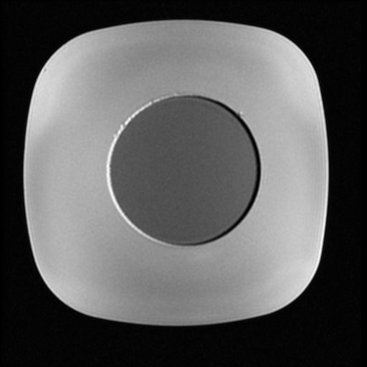
The images above are of a phantom made from tap water (outer circle) and olive oil (inner circle) with a T2 weighted FSE, with the frequency encoding direction set R/L. Bandwidth is increased from 10 kHz up to 63 kHz. Notice with low bandwidths the SNR is high, but the chemical shift artifact is significant. As bandwidth is increased, the SNR becomes worse, but the chemical shift is reduced. Looking closely at the top right corner, it is also apparent that some geometric distortion occurs with low bandwidths. As bandwidth increases from low to high, it is also noticeable that some T2 weighting is lost and the CNR between the olive oil and tap water is reduced. This is the to the high bandwidths shortening the echo spacing, and reducing the maximum TE's contributing to the CNR; this is more noticeable in the phantom as the T2's of tap water and olive oil are fairly different than Fat and CSF in patients.
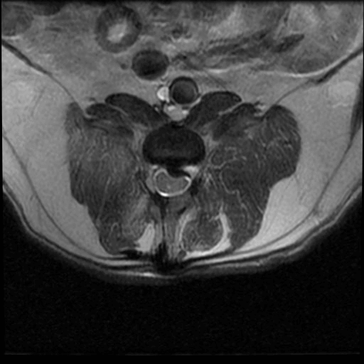
The images above are of an Axial T2 weighted FSE, with the bandwidth increased from 10 kHz to 63 kHz. Notice that the first low bandwidth (10 kHz) result in quite a blurry image; the echo spacing is long and the chemical shift artifact is significant. As bandwidth is increased, note how the morphology of the extruded disc appears to change. Also note that the 'bulk' of the patient appears to move within the image; this is the effect of chemical shift across the entire image. Once the 63 kHz bandwidth is reached, the SNR is poor and zipper artifacts appear in the image. When balancing parameters for bandwidth, there is no one size fits all rule. It will be sequence, field strength, and purpose dependent. For a general fast spin echo on a older to mid-age 1.5T scanner, set a frequency matrix appropriate for the body part being imaged, and increase bandwidth to get near ~1 pixel chemical shift/8-12ms echo spacing.

