Echo Train Length

What is Echo Train Length
Echo train length (ETL), also known as turbo factor, determines the number of additional refocused echoes to be acquired in a spin echo based sequence and is used to decrease scan time. Depending on the sequence, this number can be selected by the user (as in FSE) or is controlled indirectly (as in HASTE) through other parameters such as phase encoding steps. When selecting an echo train length, it is important to remember that the refocused echo is created from an additional refocusing RF pulse. As will be discussed further down, this can have implications for controlling SAR and TR. This page will primarily focus on echo train length as used in the fast spin echo.
Consider 1 slice of a T2 weighted spin echo sequence with a phase encoding matrix of 256; to fully acquire the image 256 lines of k-space are needed, and will be acquired 1 line at a time. For an example, if the TR is 3000ms, this will need to be repeated 256 times: 3000msx256 = 768,000ms or ~12.8 minutes. This is quite inefficient, as only 1 echo is acquired with each TR, and the rest of the TR is just spent waiting. To reduce imaging time, let's acquire 16 echoes within that 3000ms TR, the math now looks like this: (3000msx256)/16 = 48,000ms or ~48 seconds. Much faster!

Echo Train Length and Effective TE
When using a fast spin echo, the TE parameter behaves differently than in the traditional spin echo. The selected TE is now one of multiple echoes, and is placed at the center of k-space which allows it to dominate the image contrast; this is known as the 'Effective' TE. Unlike a traditional spin echo where there is only 'waiting time' before or after the TE, the fast spin echo will always start with the shortest TE and extend out to the end of the selected ETL. For example, in a fast spin echo where the shortest echo is 10ms and there is a 10ms space between each echo, an ETL of 12 will result in echoes at 10ms, 20ms, 30ms, 40ms, etc until 120ms. Any of those echoes can be selected as the effective TE and placed at the center of k-space. There a few important things to take away from this behavior:
- There are multiple echoes at varying TE values that will be acquired during a fast spin echo, always
- The effective TE is the primary echo contributing to image contrast, but not the only echo that can influence it
- Only the minimum, maximum, and echoes between those end points can be chosen as the effective TE
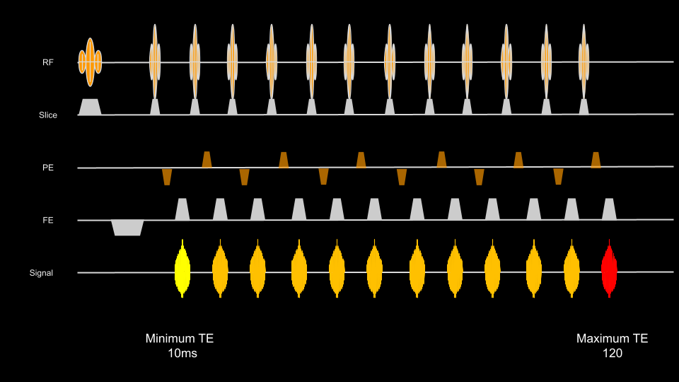

Selecting an appropriate ETL
When selecting the ETL, it is important to consider the contributions of all the echoes within the ETL to image quality, as there are some special behaviors that occur with trains of RF pulses and echoes. Very long ETL's will result in echoes that may extend out far beyond the desired effective TE. The further out the echo, the more T2 decay will occur and the 'quality' of the echo will degrade and contribute to image blurring. Additionally, a long ETL means that many more refocusing pulses will be required; this will increase SAR and also lead to some degree of tissue saturation and magnetization transfer effects. Long ETL's also take up significantly more space within the TR, so there will be a tipping point where increasing ETL will no long decrease imaging time, as the TR will have to be increased to make room for all the additional echoes. Below is an example of a T2 fast spin echo with different ETLs: 13, 24, 32, 64. Notice how edge details rapidly become blurred as the ETL is increased, and the blurring is prmarily in the phase encoding direction. Keep an eye on the maximum TE when selecting the ETL, it will increase rapidly as ETL is increased. In general, select the shortest ETL possible to achieve a reasonably short scan time and appropriately selectable TE's.
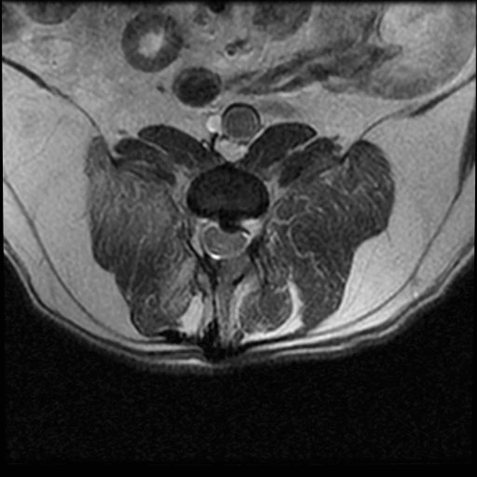
Guidelines
- T1 Contrast: ETL 2-4, Maximum TE ~30ms
- PD Contrast: ETL 7-11, Maximum TE ~100ms
- T2 Contrast: ETL 16-24, Maximum TE ~200ms

Selecting the Effective TE
So, which echo is the best echo in the echo train? Generally speaking, it is good to select an effective TE near-ish the midpoint of the echo train, at a time appropriate for the desired contrast. Very early echoes do tend to demonstrate some degree of blurring, and greater flow artifacts. TE's around the mid point of have achieved more signal stability , influences from both stimulated and refocused echo signals, and tend to have sharper edge details. This behavior can even be seen in relatively short ETL's! The gif below is a T1 FSE with 4 echoes, 8ms apart, therefore TE's at 8ms, 16ms, 24ms, and 32ms. All parameters are constant other than the effective TE. Note how the flow artifact from the vessels decreases as the effective TE is longer, and how the edge details become more crisp. The second gif on the right is a T2 FSE with min/max TE's at 10ms and 180ms. Although it's a broccoli, the edge detail changes are still demonstrative of this behavior. Very late TE's may suffer from too much signal loss due to T2 decay.
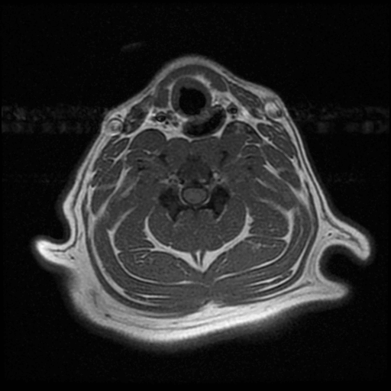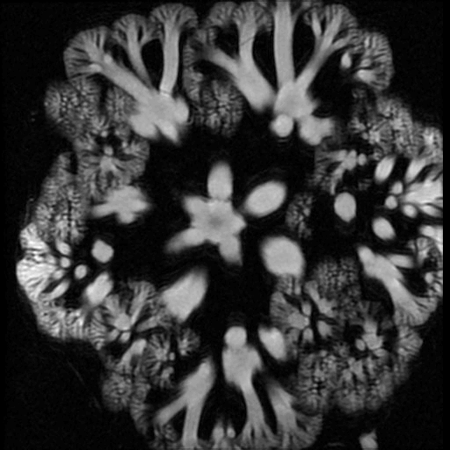

Combining ETL and Effective TE Choices
Broadly, image quality will be acceptable across a pretty wide range of Effective TE and ETL combinations as long as no single parameter is pushed to the extreme. In this grey area, there is nuance, trial and error, and even individual scanner behavior. In the example below, different combinations of TE and ETL are chosen, all within the normal acceptable ranges of 2-4 ETL and an effective TE under 30, notice how much variability there is even within the recommended ranges!
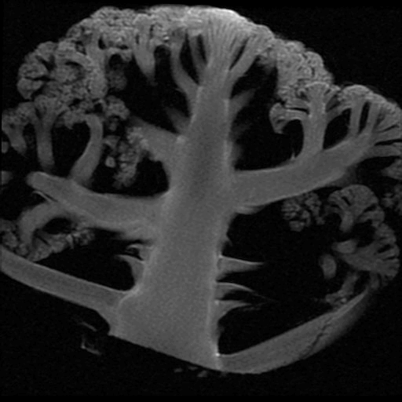

ETL and Specific Absorption Rate (SAR)
The SAR model used by most scanners tends to be inaccurate in the setting of small animal scanning, in part due to the much smaller patient weights. Typically the ETL is comprised of 180 degree refocusing pulses that will contribute to patient heating and lead to high SAR calculations, which may force the scanner to pause in the middle of a sequence. To reduce actual and estimated patient heating with small animals, it is often necessary to reduce this refocusing flip angle. In practice, this parameter change will have relatively little effect on image contrast and can be as low as 110 degrees. In T2 weighted sequences the longer TR will tend to balance out the RF heating from the refocusing pulses, but this is not the case with the shorter TR of T1 weighted sequences, especially if multiple T1 weighted sequences are to be run in succession.

Indirect Parameter Effects
In MRI, no parameter exists in isolation. There are of course other parameters that will affect aspects of echo train length and the effective TE.

Bandwidth
The most influential secondary parameter will be receiver bandwidth. This parameter will affect the sampling rate, and therefore how long it takes to fully sample each echo. As bandwidth is increased, the length of time taken to fully sample an echo will decrease. This will have the effect of reducing the time between each echo, known as the echo spacing, which will also reduce the maximum and minimum TE's. This will also have the effect of reducing chemical shift artifact and improving edge details. For most older scanners, a good guideline is to try and keep the echo spacing around 8-12ms. For more information on bandwidth, see here.

Frequency Encoding Matrix
The frequency encoding matrix will determine how many samples are to be taken within the FOV at a rate determined by the bandwidth. If the frequency matrix is increased, the time needed to fully sample the echo is increased, so the echo spacing and maximum TE will be increased.

Special cases: Single Shot Imaging with HASTE
Single Shot Fast Spin Echo sequences take the ETL to the extreme; instead of the required phase encoded steps being 'chunked' into a neat echo train and then repeated over multiple TR's, HASTE and similar sequences acquire every phase encoding step in a single TR, resulting in an echo train length that is equivalent to the total number of phase encoding steps. In these sequences, if a phase matrix of 256 is chosen, the echo train length may be as long as 256, although this is frequently shorted by a number of different techniques. Parameters that will affect the phase encoded steps , and therefore the echo train length, are as follows: Phase matrix, Phase FOV, Parallel Imaging, and Partial Fourier.

