Time to Repeat (TR)

What is TR?
Time to Repeat (TR) is the time between successive excitation pulses in the same slice. It is a user selectable parameter that primarily controls the amount of longitudinal relaxation allowed to occur within a pulse sequence. Appropriate TR's depend on the particular pulse sequence and contrast, so each will be addressed separately below.

TR in Fast Spin Echo
In an FSE sequence TR primarily controls the amount of T1 weighting allowed to influence image contrast. Shorter TR's (400-700) will increase T1 contrast by saturating tissues with long T1 times, and long TR's (3000+) will reduce T1 weighting by allowing all tissues time to recover most of their longitudinal magnetization. Secondarily, the TR will affect the maximum number of slices per TR and the maximum ETL. Longer TR's will allow for more slices and longer ETLs, while shorter TR's will require slices be broken up into multiple acquisitions. SNR will also be affected by TR selection; as TR is increased, more longitudinal magnetization is recovered and available to be converted into transverse magnetization. This effect can be seen even within relatively short TR ranges. In the images below, TR is increased from 400 to 4000ms; note how both SNR and image contrast evolve. Further, notice how the CSF signal remains relatively dark until almost 4000ms.
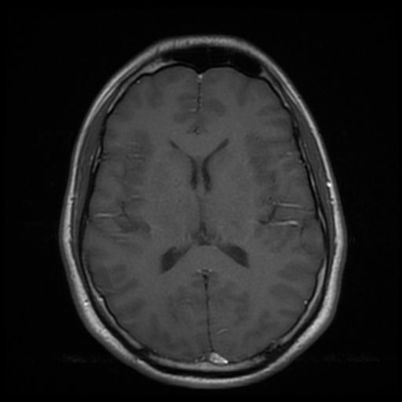
- T1 weighting: 400-700ms
- Proton Density weighting: 3000ms+
- T2 weighting: 3000ms+ (1500+ with Restore pulse)
- T2 FLAIR: 9000ms+
- T1 FLAIR: 1800ms+
- STIR: 3000ms+

Driven Equilibrium/Restore Pulse
This technique is common in spine imaging, and is an option available on almost all scanner generations. At the end of the echo train, an additional -90 degree RF pulse is tacked on to force any remaining magnetization back toward equilibrium. This in effect replaces the the waiting period (the 3000+ TR) needed for T1 recovery, allowing much shorter TR's to be used with heavily T2 weighted images. With typical parameters, fluids will also be brighter than they normally would with comparable TE's.

TR in Fast Gradient Echo
When TR's become very short (<T1 and T2), a steady state can be achieved with the longitudinal magnetization. This means that after each TR, the same amount of longitudinal magnetization is recovered as is lost to RF excitation. To prevent total saturation of the signal, lower flip angles (5-15 degrees) are used. When utilizing these sequences, the TR may not be selectable and is no longer the primary parameter controlling image contrast, instead flip angle, spoiling, and sequence type will be most important.

TR and Specific Absorption Rate
Specific Absorption Rate (SAR) is an estimate of how much RF energy will be deposited into the patient over a certain length of time scanning. One of the many factors that can affect the calculated SAR is the TR and the number of slices. A lower TR will mean that RF pulses are more closely spaced together, depositing more RF energy into the patient. A SAR limit may be reached when the TR is low and a large number of slices is used, especially post contrast imaging, where most sequences are T1 weighted. To counteract this, a slightly longer TR can be selected to build in some 'dead time' into the sequence, at the cost of scan time. There are other more effective means of managing SAR limitation with small animal imaging to be found Here.

