Playground
This is where we play with DokuWiki

Main Gallery
Playing with a photo gallery function. It is possible to have multiple galleries, each within a namespace.
And playing:
Array
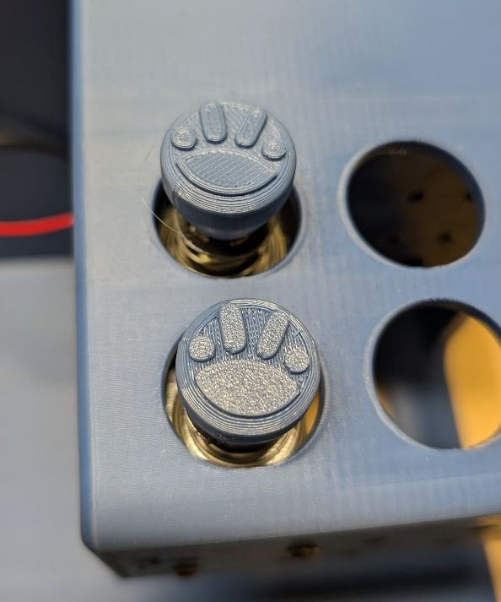Array
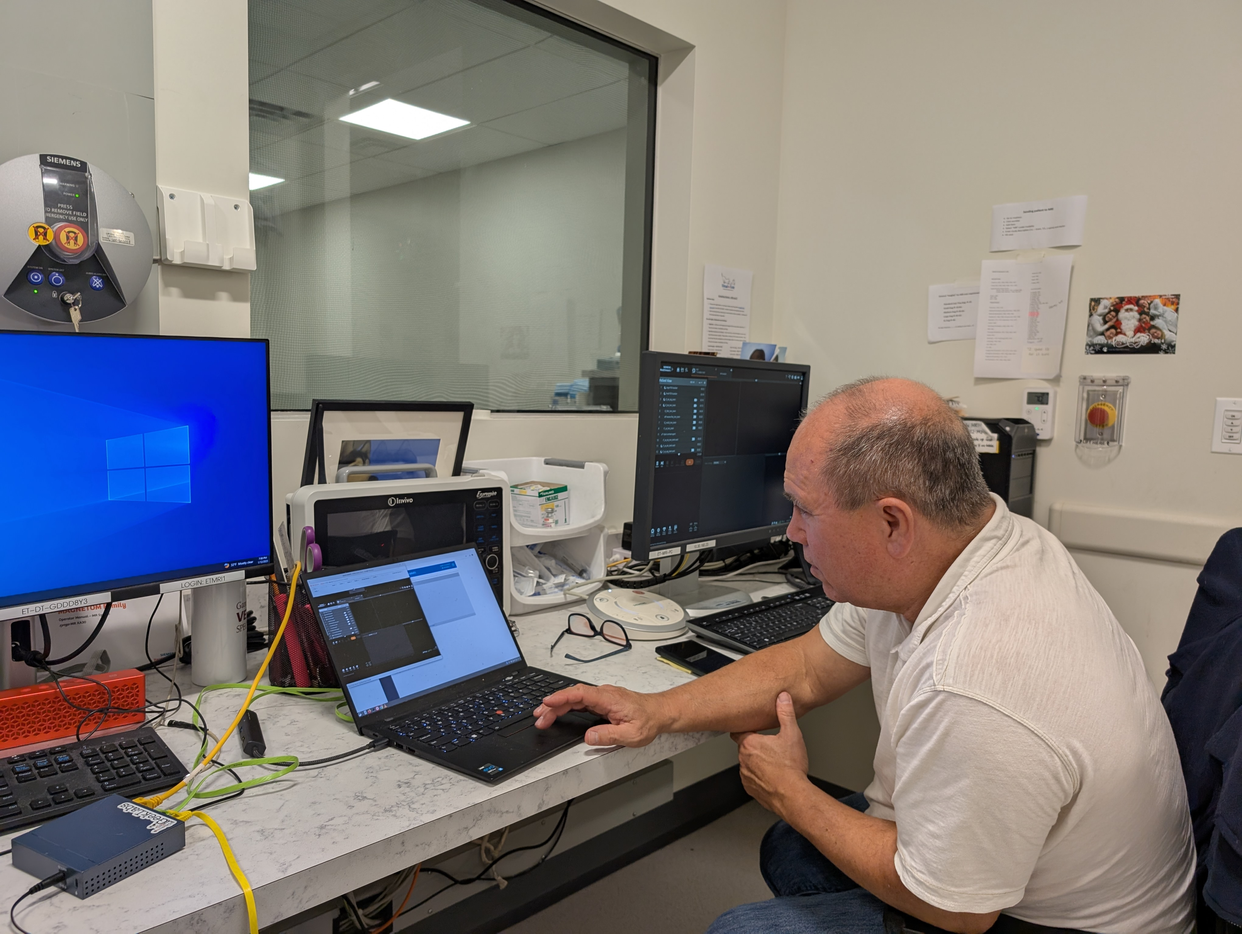Array
Array
Docs: https://www.dokuwiki.org/plugin:photogallery
option fullsize works nicely if all images are the same size.
might want to set the fade between pics to zero?

