Other Spine Diseases

More Than IVDD
There is more to spine pathology than just IVDD! On this page, there will be case examples of non-IVDD pathology in the spine, and a list of any useful sequences.

Discospondylitis
Discospondylitis is an infection of the vertebral endplates and intervertebral disc, most commonly of bacterial origin. Some notable features are:
- Collapse of the IVD
- STIR/T2 hyperintensity
- Contrast enhancement
- Paravertebral inflammation or fluid like collections
- sclerotic changes to vertebrae
Useful sequences:
- STIR
- T1 with and without fat saturation
- T1 post contrast with fat saturation
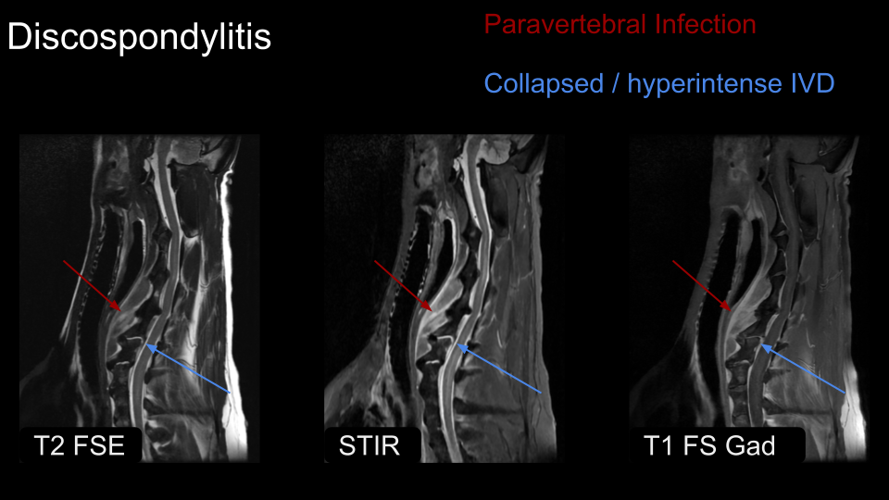

Arachnoid Diverticulum
Some notable features of arachnoid diverticulum:
- Scalpel sign
- Gliosis
- Lesion demonstrates CSF signal characteristics
Useful Sequences:
- 3D Myelogram
- 3D FIESTA-C / CISS
- Sag T2 FSE
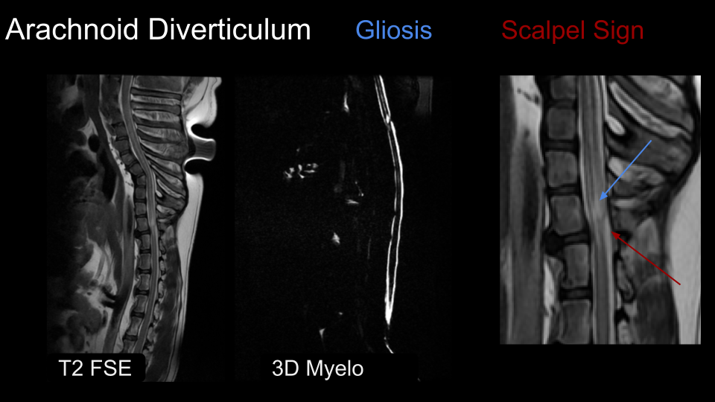
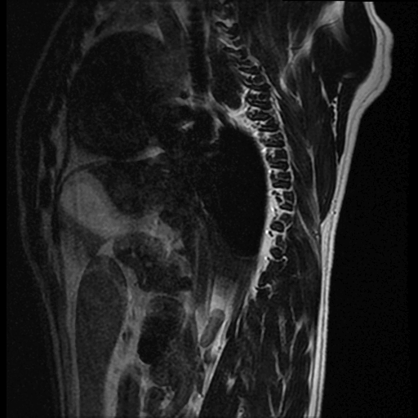
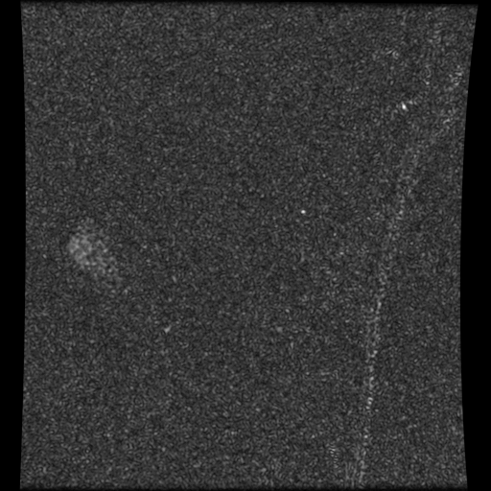

Fibrocartilaginous Embolism (FCE)
FCE is like a 'stroke' in the spinal cord; a small piece of IVD embolizes into a small spinal artery and occludes blood flow leading to ischemia or infarction in the spinal cord.
Notable Features:
- Sharply Demarcated
- Grey matter affected
- Can be linear
- Possible hemorrhage
- Swelling of the spinal cord
- Possible gad enhancement
- T2/STIR hyperintensity
Useful Sequences:
- T2 or STIR
- T1 Post Gad
- T2* if hemorrhage
- DWI if specialized sequences are available
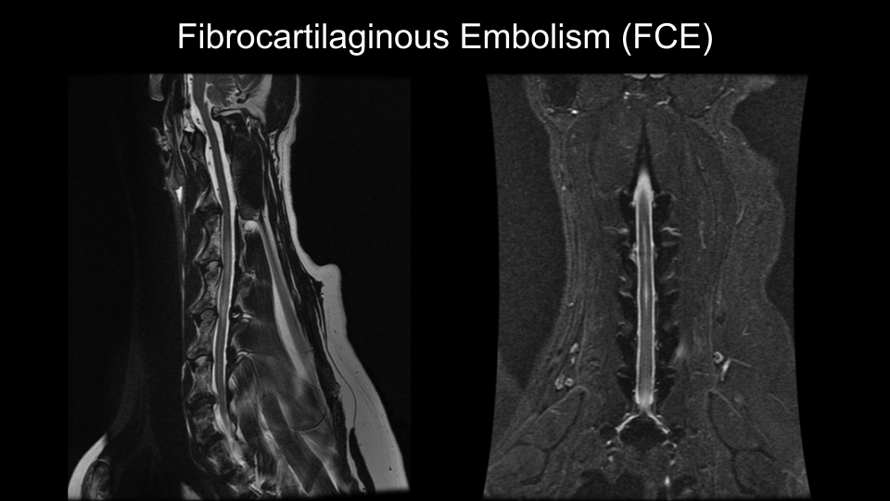
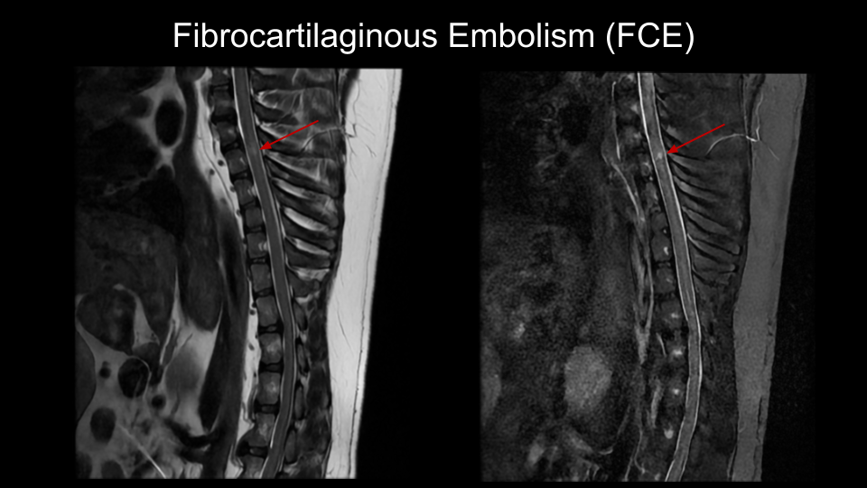

Neoplasia
Neoplasia can occur anywhere in the body, and the spine is no exception. When there is neoplasia in the spine, it is important to try and discern the location of the tumor:
- Intramedullary; within the spinal cord
- Intradural Extramedullary; originating from the dura surrounding the spinal cord
- Extradural; originating from outside the spinal cord and it's dura

