Welcome
This wiki is provided and information shared by the Virtual-Scan.com team and friends. Our goal is to provide a comprehensive wiki sharing everything we can about how to do Veterinary MRI.
We are starting to add raw content to the Veterinary MRI Protocol Library. We intend to organize it better as we we learn how to use this wiki effectively.
It's getting better every day.

Main Gallery
Playing with a photo gallery function. It is possible to have multiple galleries, each within a namespace.
And playing:
Array
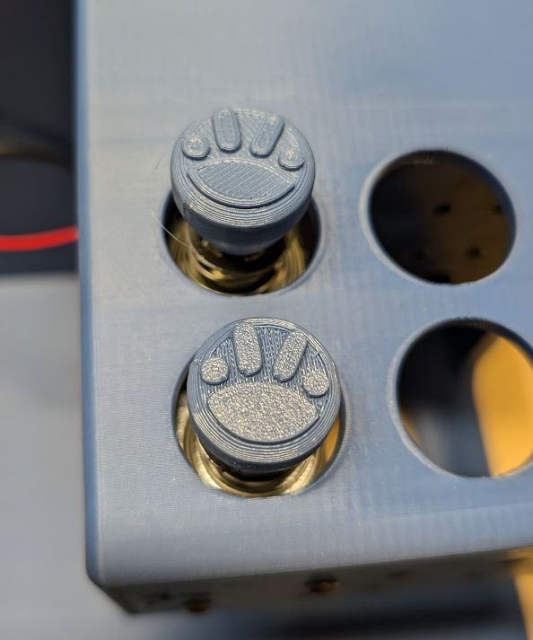Array
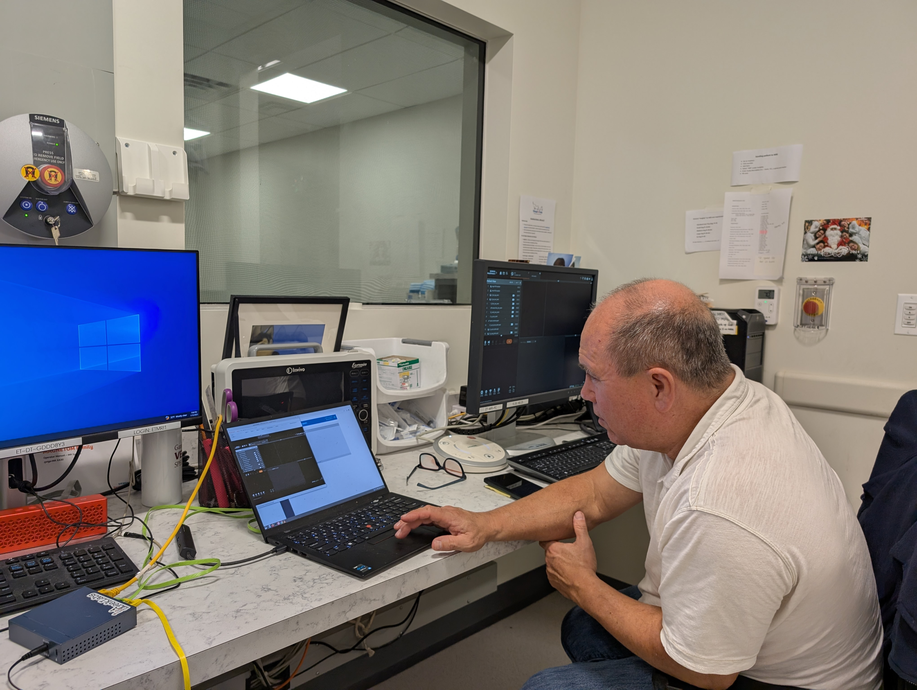Array
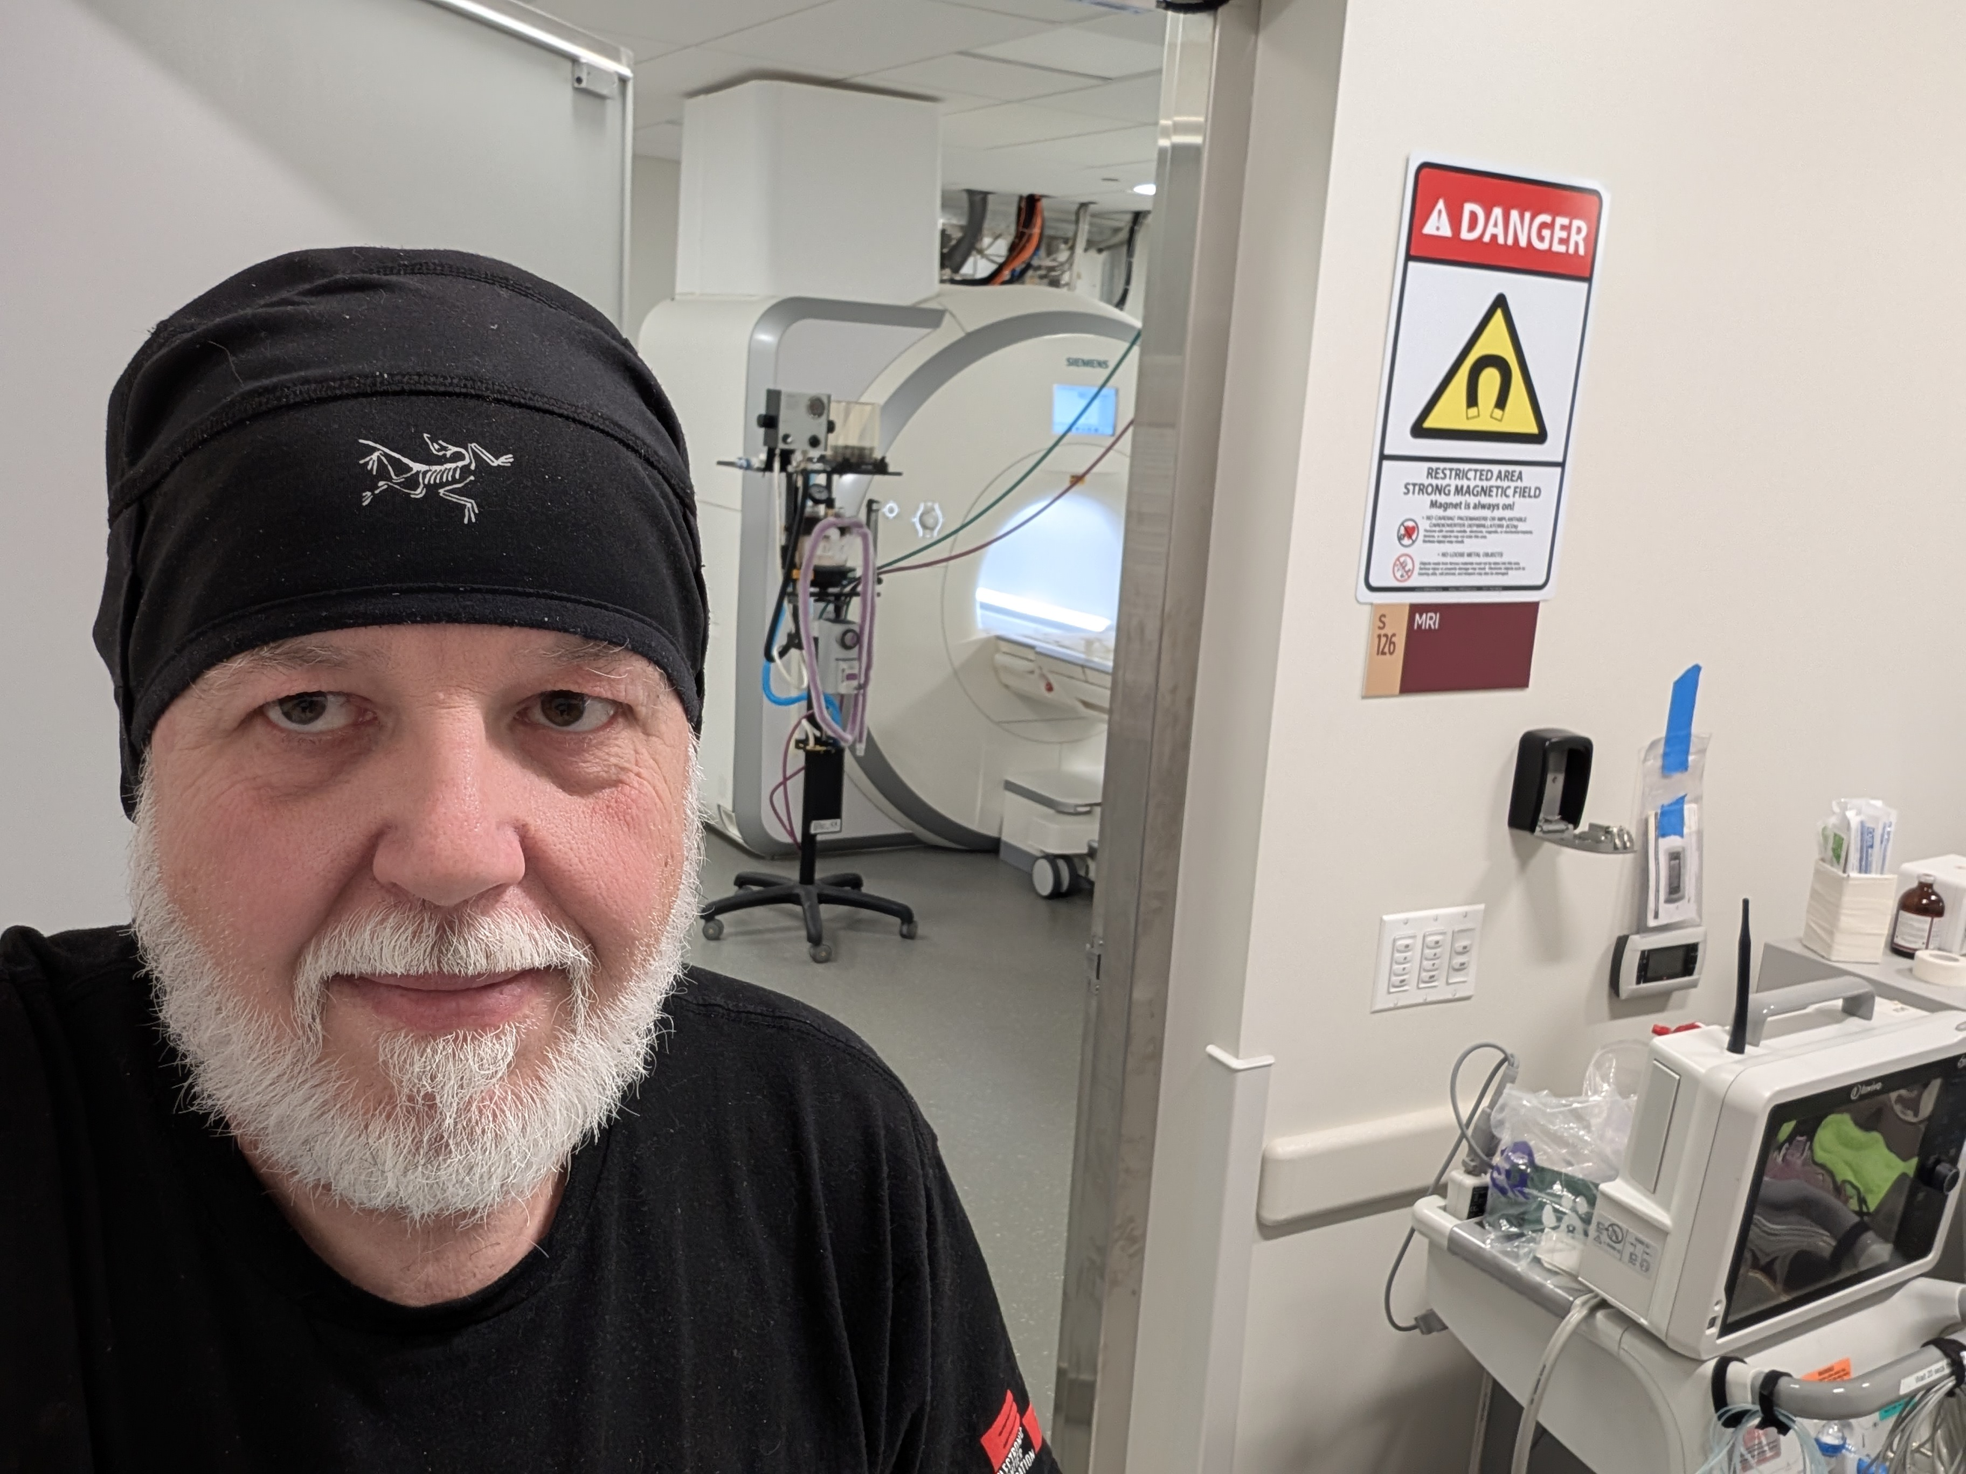Array
Docs: https://www.dokuwiki.org/plugin:photogallery
option fullsize works nicely if all images are the same size.

The Blog:

