Virtual Scan Voyager User Guide
Sharing publically how to use the Virtual Scan Voyager Client Interface to request a scan. It's not useful unless an installed customer, but if you are exploring how Virtual Scan can help you, this is how we operate.

Become a customer
It's a process, we can interface with most MRI and CT systems, both Unix and Microsoft systems: Start by contacting us at;: https://www.virtual-scan.com/contact

Login
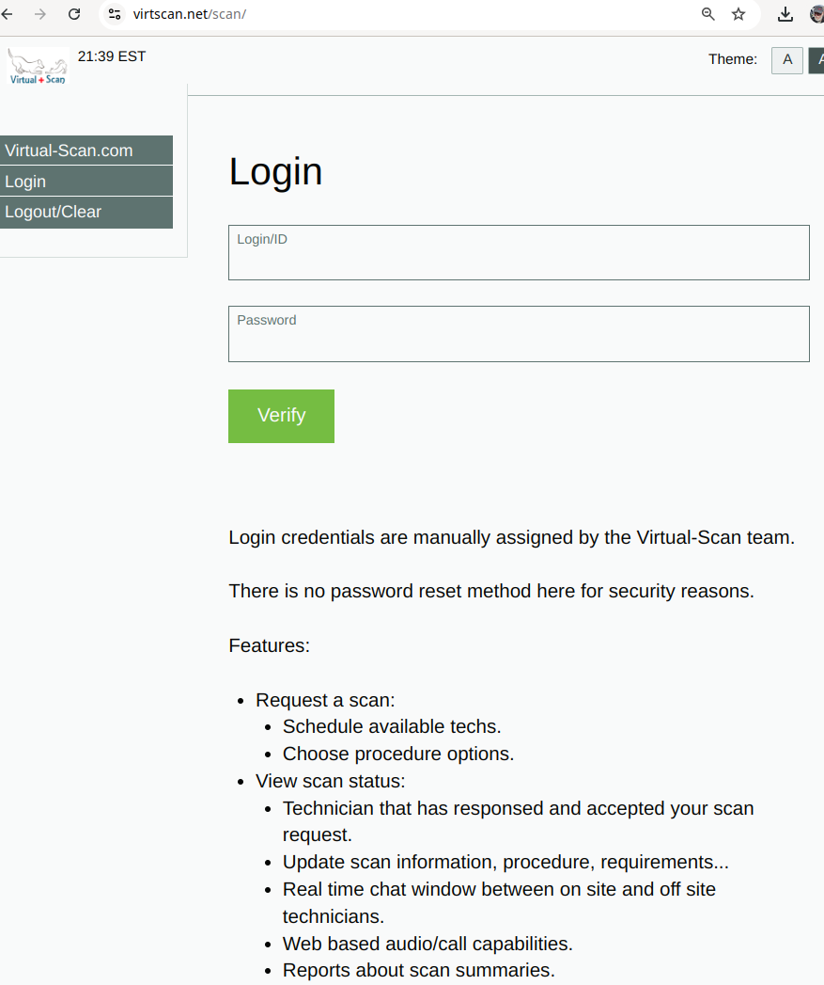
As a customer, you can use your assigned login and password to request a scan at: [https://virtscan.net/scan]] In some cases, the system will lauto-recognize the site by IP address and other factors. Each site gets 1 login.

Dashboard / Request
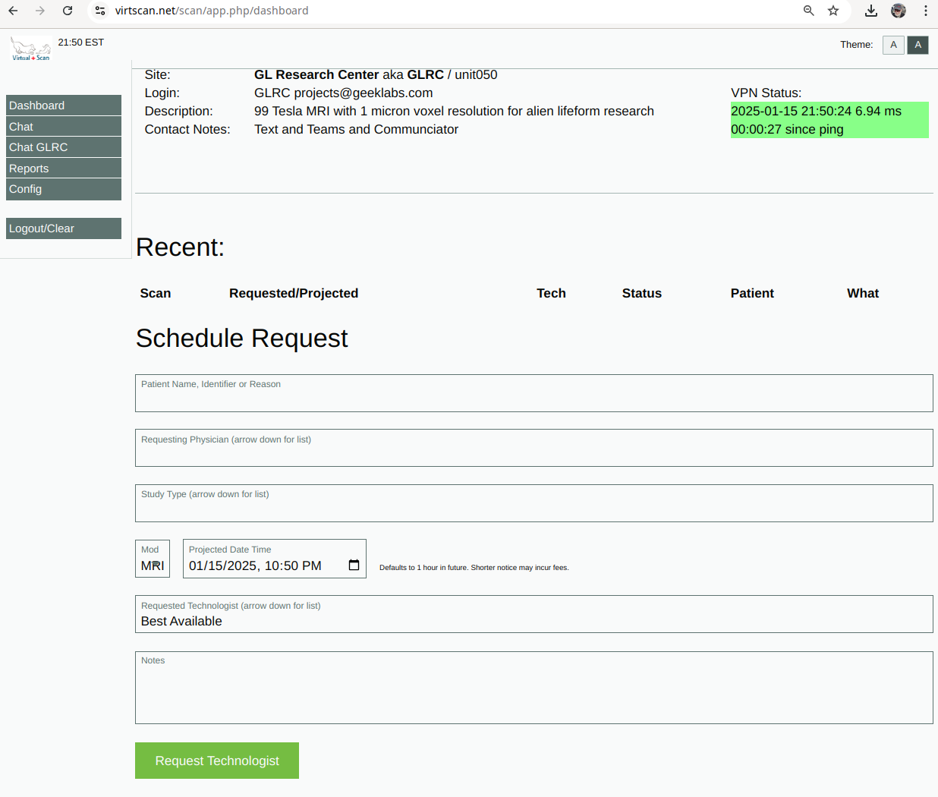
Once logged in, you can use a form to request a scan. This notifies all available technologists via SMS/Text as well via the Virtual Scan Communicator our web based chat, voice, phone call and screen sharing system.
On your dashboard you can monitor your open requests as well as the acceptance and scheduling of your request,

After the Scan
You will have detailed scan summaries and reports.

Communicator
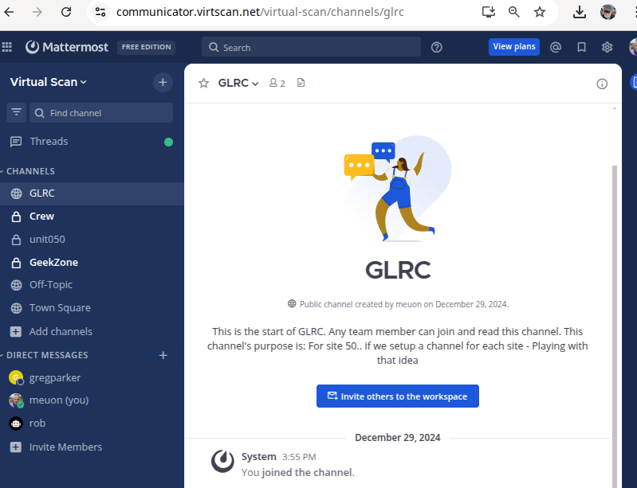
Communicator is our central communications system where you will be chatting with your technologist in real time, and can call/voice/video and screen share if needed.

